Sleaford Rugby Football Club
Committee structure with roles and responsibilities


SRFC Core Values

SPORTSMANSHIP
- We maintain a positive attitude in all aspects of the sport.
- We play for fun and create a positive culture.
- We are always accountable, maintaining discipline.
- We play to win, develop and grow.

RESPECT
- We have self-respect: we are punctual, enthusiastic & willing to learn.
- We respect and support each other through adversity.
- We respect match officials and their decisions.
- We respect our facilities and keep all areas clean and tidy.

COMMUNITY
- As a Club, we embrace our role in enriching the lives of everyone.
- We aspire to be role models and ambassadors for the local and wider Lincolnshire area.
- We inspire the local community by promoting the club and our values.
- We grow our club through our people & support everyone to maximise their potential.
- We are loyal through how we act for each other & our wider community.

FAMILY
- We are a Team: we play and win for each other.
- We are a Club: we are there for each other.
- We are open to change and assist our club mates in actions.
- We are inclusive and have the courage to defend our values and morals UNITY
- We support each other and offer help where it is needed.
- We listen and respect the views of others.
- We are loyal, we care, we respect.
- We are continually developing to be better people and players.

SRFC Roles and Responsibilities

It's crucial to make sure volunteers are assigned to positions that play to their strengths and personalities in order for them to appreciate and enjoy their involvement in rugby.

----------------------------

All volunteers should be completely aware of the time, effort, and commitment required of them and the simplest method to achieve this is by creating an inventory of job descriptions. The primary
purpose of the set job descriptions is to minimise confusion by clearly defining responsibilities.

----------------------------

The proposed descriptions are written specifically for the requirements of SRFC and its members, both in terms of content and degree of detail. The roles are where possible in line with the RFU standards and descriptions. It is expected that these job descriptions will need to be reviewed at regular intervals to reflect club development as well as the talents and strengths offered by the volunteers and employees.

Committee Structure
(Roles and names
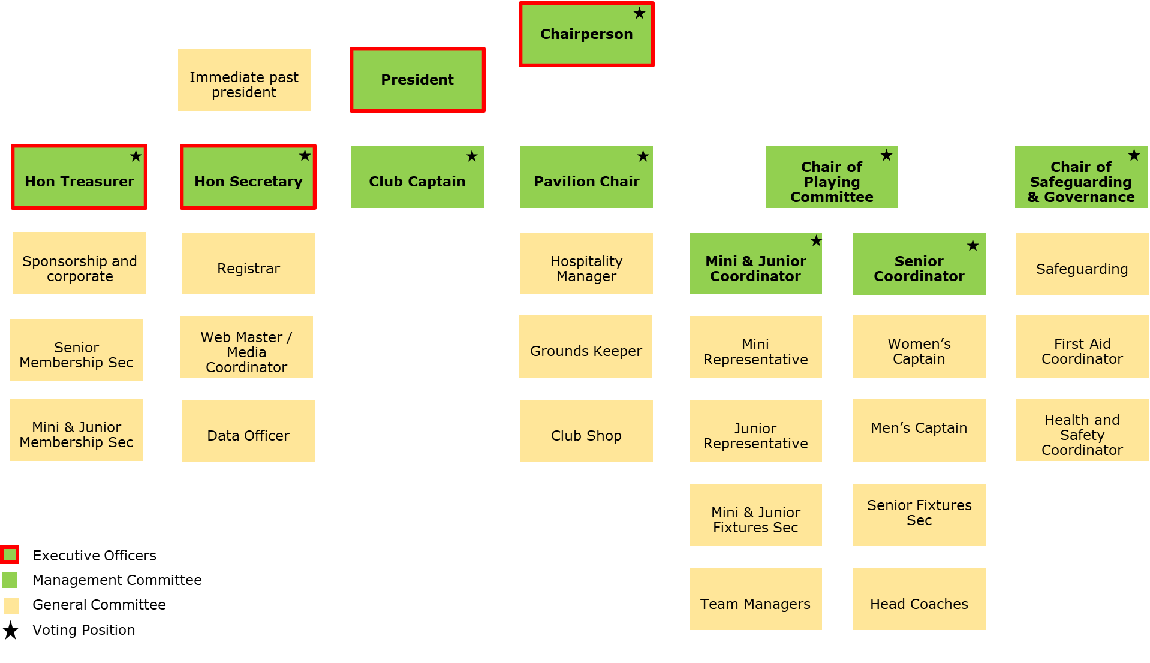
Commercial Manager
With
reference to RFU structure)

SRFC Management Committee
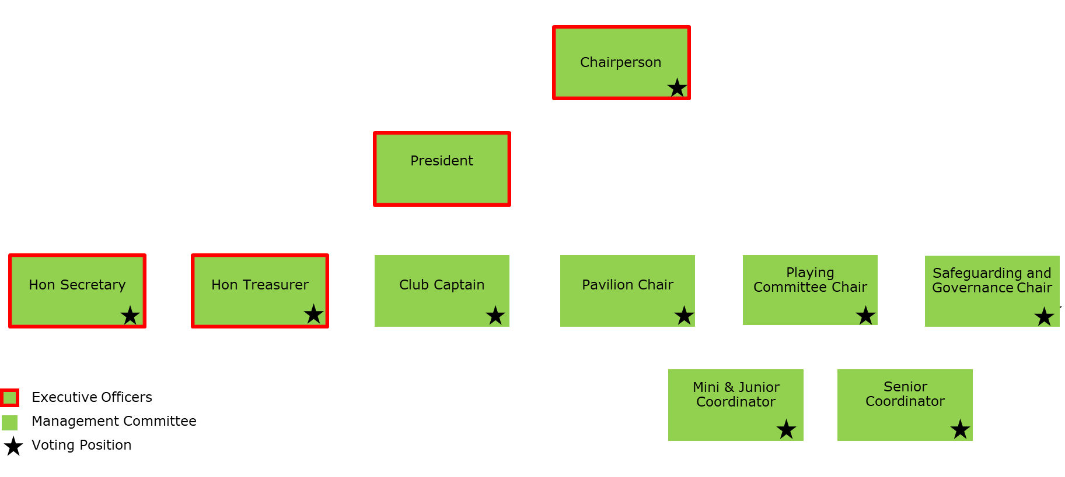
Commercial
Manager

SRFC’s management committee is a group of appointed people who are nominated to act on behalf of, and within the powers granted to them, by the members of the rugby club. The management committee is composed of the officers and management committee personnel who are chosen according to the clubs constitution. Beneath the management Committee will sit a series of Sub Committees which will give greater representation throughout the club and bring a structure that will enable the club to fulfil its mission and goals.
Any issues around the general running of the club will be discussed at these sub committees and recommendations put forward by the heads of those committees to be approved at Management Committee level.
The sub committees will be expected to collaborate with one another and, where necessary, co-opt other club members who might be able to assist with projects and the general running of the club. It is felt that by widening the representation of the clubs' organisational structure this will give each club member wider respiration, fostering greater inclusion, accountability, and openness.

SRFC Minis and Juniors Rugby Sub Committee

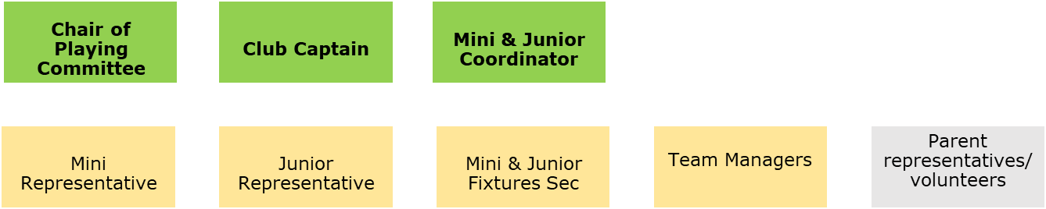

SRFC Senior Rugby Sub Committee

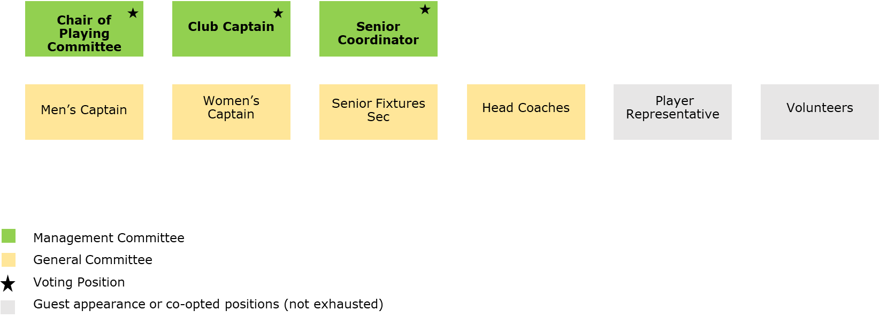

The Playing Sub Committee comprises all members who are actively involved in the development, recruitment, retention and general running of the game. The above are not exhausted positions, other members can be called upon if needed by either guest appearance or co-opted to the committee for an agreed term. The aim of these sub committees is to ensure that standards of coaching, discipline and respect are mirrored across the club with best practice being shared and replicated.
It would be recommended that these committees have regular contact via a group chat platform and face to face meetings with a structured and formal agenda quarterly. The topics discussed and any issues arising are to be taken back to the management committee to be discussed and voted on if required.

*Agenda to be created in collaboration with chair of the playing committee, club captain and section coordinators

Disciplinary Committee
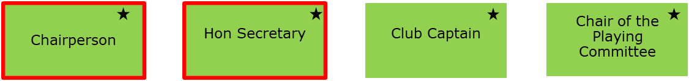
These positions may change depending on the incident and may include the club safeguarding officer or other members who are deemed appropriate.
Needs only meet for disciplinary hearings, debate and sanctions.
RFU Discipline Guidance can be found at:
DISCIPLINE GUIDANCE FOR RFU CLUBS

Finance Committee
Commercial
Manager
The club’s Finance Sub Committee’s aim is to maximise and develop all revenue streams both current and future to benefit the development of the club and its members by using its assets to their fullest potential.
To carry out an ongoing review of club expenditure and guarantee that the clubs resources are used wisely.
To formulate plans to expand the clubs sponsorship programme and make sure that we retain, for the long term, our existing sponsors.

Events Committee
Informal committee set for organising and arranging club functions and events - headed by the Pavilion Chairperson and may include Club Captain, Webmaster or any individual that is interested in the role. Events include but not limited to:
*Sponsors lunches |  | *Presidents day |  | *Minis and juniors events
*Summer function |  | *NLD events |  | *Fundraising events
*Awards night |  | *Form club functions |  | *Charity events
*Christmas event |  | *Pre match lunches |  | *Tournaments

Not all members of the general committee will need to attend formal meetings but there is an expectation that all roles report to the person in their line of the management committee in order to give feedback on any information for deliberation. It would be recommended that all sub committees have a group chat platform and only meet face to face as and when needed in order to allow for busy lives and the commitment to volunteering.

CHAIRPERSON

Purpose:
To provide vision, leadership and business planning to help develop all aspects of the club, from playing and team development to running the business and fundraising. The Chairperson could be seen as the captain of the committee setting the vision and is ultimately responsible for the achievement of its strategic aims and the club's core values.

Key aspects of the role

Arrange and lead club meetings: Arrange and chair Management Committee meetings, Emergency
Committee Meetings, Sub-Committee meetings concerning club policies and
Special/Annual General Meetings supported by the Honorary Secretary. Prepare the Annual General Report from the attended meetings throughout the year.
Attend all meetings in a neutral and uncommitted capacity and enable the group to have a meaningful discussion with a neutral person in the chair.

Implement policies and strategies: Use the latest legislation to ensure health, safety and welfare policies are implemented within the club. Lead the creation of the clubs development and business plans. Manage other Club Officers to ensure the delivery of their responsibilities. Ensure that the club structure and responsibilities are transparent and available to the membership.

Ensure club representation: Acts as ambassador for the Club, representing, or arranging for another Executive Committee to represent the Club at external meetings including NLD forums and AGM and RFU AGM.

Person attributes set by the RFU: charismatic and inspiring leader with experience in effective management and business administration, strong communication skills, and a diplomatic and discreet manner.

PRESIDENT
Purpose: The President is primarily an honorary position within the club and acts as the club’s representative and spokesperson at all internal and external functions. The president should be present and visible to its members as the figurehead of the club.

Key aspects of the role:

Act as the figurehead of the club: be the welcoming face of the club, set an example that influences the way the club is perceived and represent the club at internal and external functions. Communicate and abide by the club's core values to all members of the club.

Provide advice and assistance as required: Act as chairperson of the committee in the absence of the chair. Provide advice and assistance to any of the officers of the committee as required. Act as a member of any sub-committee if required.

Person attributes set by the RFU: a confident and charismatic personality, with strong communication skills, with prior exposure to good business practices, as well as a strong understanding of the club.

Notes: Would step in to deputise for Chairperson in their absence.

HONORARY SECRETARY

Purpose
To provide an efficient administration service to the club, ensuring the club functions smoothly and effectively and be the main communication link between internal and external stakeholders, including the Committee, sub-committees, club members and other clubs/leagues

Key aspects of the role

Manage and maintain record keeping: Manage all inward and outward club correspondence; manage all legal and insurance matters, in conjunction with other relevant members.

Lead meeting organisation: Supported by the Chairperson organise the AGM, Management Committee and club meetings. Preparing agendas and paperwork, taking minutes and ensuring the distribution of the right paperwork to relevant individuals in the club.

Maintain communication between other bodies: Communicate any important matters between the RFU, CB and leagues, demonstrating a thorough understanding of the rules of each respective body and provide all details as necessary to the RFU and your CB.

Person attributes set by the RFU: a capable manager who gets things done through strong communication, IT and delegation skills, as well as experience in administration and meeting procedures.

HONORARY TREASURER
Purpose
To manage club finances, contribute to strategic business planning and review and recommend financial policies for the club to ensure that the finance work appropriately for the club.

Key aspects of the role

Lead on all financial issues: Plan and monitor a budget each year; prepare and present the accounts for the end of year financial report and keep the committee informed of any trends and issues. If relevant, manage the club investment portfolio.

Manage financial transactions, subscriptions and contracts: Prepare and submit any relevant statutory documents, including VAT, tax, grant reports, etc. Renew insurances annually and ensure the club has paid relevant affiliation fees. Working in conjunction with the membership secretary, monitor membership subscriptions income.

Monitor commercial activity: In conjunction with the bar manager, monitor bar or hall hire, catering etc. Deal with suppliers, coordinate timely payments and ensure that all appropriate documentation is obtained.

Person attributes set by the RFU:financially knowledgeable, with skills covering bookkeeping, accounting, VAT returns, PAYE with accurate record-keeping, computer and numerical skills.

COMMERCIAL MANAGER

Purpose:
To provide commercial vision, leadership and business planning to help develop all aspects of the club, focusing on the running and growth of the business . The Commercial Manager could be seen as the lead for the future growth of the club, setting the growth vision and is ultimately responsible for existing & new revenue opportunities.

Key aspects of the role

Arrange and lead club meetings: Arrange and chair commercial & partnership meetings, supported by the Honorary Secretary & Honorary Treasurer and feedback to the main committee.

Implement commercial policies & growth strategies: Lead the club’s business development and growth plans. Manage other Non-Officers to ensure the delivery of commercial projects. Ensure that the club is financially sustainable whilst supporting the Honorary Treasurer.

Revenue Generation: Driving income from hospitality, events, facility hire & partnerships.

Marketing & Promotion: Enhancing the club's brand & community presence.

Person attributes set by the RFU: Business leader with commercial acumen and sales drive, with experience in effective operational management and business administration, strong communication & networking skills to deliver professional partnership proposals in a diplomatic and professional manner.

CLUB CAPTAIN

Purpose
To act as the role model at the club, acting as the link between players and the administration and in such a role representing the views of players

Key aspects of the role

Liaise between players and administration: Represent players on the Management Committee and Disciplinary Committee if required; ensure all players are aware of codes of behaviour on and off the field; inform the players of administrative arrangements and
encourage players and other club members to get involved with voluntary work and social activities at the club

Lead, advise and support the team: Be part of selection meetings, help the coach organise training and player development were appropriate, be the initial point of contact for new members, and lead, advice and support fellow team mates

Wider club role: Be the face of the senior section for the mini/junior section. Encourage players to become assistant coaches on Sunday’s with younger players. Is this role for you?

Person attributes set by the RFU: familiar with the club and players, committed to fair play, enthusiastic and dedicated with good communication skills.

Notes: Would deputise for President in their absence

PAVILION CHAIR

Purpose
To manage and coordinate the running of the pavilion. Develop revenue streams in order to develop the club, using its assets to their fullest potential.

Key aspects of the role

Generate income for the club: Through a maximisation of club assets, generate income for the club i.e. opening up the club to the wider community for functions like corporate events, weddings and parties supporting the Commercial Manager.

Minimise costs: Look for the most cost effective way to run the club in order to minimise expenses.

Manage risk: Ensures that ongoing H&S and Fire related tasks, e.g. checking fire extinguishers, conducting fire drills, checking water temperatures, checking the cold water tanks, checking toilet cleanliness, are conducted as required to abide by H&S protocol and ensure the results recorded.

Person attributes set by the RFU: experienced in business, resourceful and dedicated with strong numerical and communication skills.

CHAIRMAN OF THE PLAYING COMMITTEE (RFU position is Director of
rugby)

Purpose
To provide leadership of coaching resources and the coaching of individuals and teams to achieve success on and off the field.

Key aspects of the role

Implement processes that will facilitate player and coach development Set up a process to identify, develop and retain all players through a high quality rugby experience; promoting the club to potential players; implement processes across the whole club to ensure a safe playing environment is created, optimising fitness and conditioning, preventing and evaluating injuries, and coordinating training and recovery sessions

Maintain the club philosophy and standards Create Team Standards consistent with the values of the game; set a playing philosophy that recognizes the teams’ strengths and is aligned to player motivations; establish a transparent selection policy

Ensure accurate reporting Complete an annual written report that evaluates the selection criteria, game plan, strategies and player progression.

Person attributes set by the RFU: have a strong team ethic, display personal discipline, pride and selflessness, are hard-working and well-organised and can communicate clearly with players, support staff, management and media both on and off the pitch.

CLUB SAFEGUARDING OFFICER (CSO)

Purpose
Safeguarding is a term used to describe measures that help keep children and adults at risk, free from abuse or harm in the game. Safeguarding in Rugby is everyone’s responsibility. Whilst safeguarding in rugby is everyone’s responsibility, the Club Safeguarding Officer (CSO) is responsible for championing safeguarding at Sleaford Rugby Football club . The CSO is responsible for championing the safety and welfare of all children and adults at risk at the club. Every person at SRFC has the
responsibility to adhere to their safeguarding duties, as per the Rugby Football Union (RFU) Safeguarding Children Policy and Regulation 21 SAFEGUARDING CHILDREN POLICY

Key aspects of the role

It is identified by the RFU that there key roles and responsibilities for this position are extensive so please refer to the following link for all the details.
https://www.englandrugby.com//dxdam/ac/acedc7fd-500d-4c00-bac6fcbd344f1c92/Safeguarding%20Officer.pdf

Requirements: The CSO must:
- Be a member of the club and attend the appropriate committee meetings
- Attend an ‘In-Touch’ training course within three months of taking up the post
- Be subject to a Disclosure and Barring Service Check, with an enhanced check of the barred
lists
- Ideally, not hold a role in the club where they’re in a position of trust or influence over children or adults at risk. There must be a clear line of reporting concerns open to children and adults at risk. Therefore, if the CSO is in a position of trust or influence at the club, there must be an assistant in place.

MINI & JUNIOR RUGBY CHAIRPERSON

Purpose
Lead effective and efficient delivery of mini and junior rugby at the club.

Key aspects of the role

Lead the development of mini and junior rugby Create and lead a team of people to deliver rugby for Tots -17 year olds; arrange and chair Mini and Junior Committee meetings and ensure that Mini and Junior members are represented within the Main Committee and CB meetings.

Organise suitable playing and training opportunities Work alongside other club officers to coordinate the running and playing of Mini and junior rugby training, games and tournaments in line with Age Grade Regulations.

Ensure all members are familiar with the core values of the game Make sure players, coaches, volunteers and parents are familiar with the core values of the game. Is this role for you?

Supports development from Juniors to senior rugby by integrating the teams with support from the Senior Coordinator. Working with the Chairman of the playing committee to ensure that the playing style and stands are mirrored throughout the club in order to minimise disruption when moving up.

Person attributes set by the RFU: Experienced and effective manager that is well acquainted with the running of the club with strong communication skills, friendly and approachable with a diplomatic manner.

Notes: Works closely with and reports directly to the Chairman of the playing committee (RFU term Director of rugby).

SENIOR COORDINATOR

Purpose
Lead effective and efficient delivery of senior rugby at the club.

Key aspects of the role

Ensure all members are familiar with the core values of the game: Make sure players, coaches and volunteers are familiar with the core values of the game

Lead the development of senior rugby: Support the Chairman of the Playing Committee to lead a team of people to deliver rugby for seniors; including fixtures, managers, coaches and volunteers.

Supports development from Juniors to senior rugby by integrating the teams with support from the Senior Coordinator. Working with the Chairman of the playing committee to ensure that the playing style and stands are mirrored throughout the club in order to minimise disruption when moving up.

Person attributes set by the RFU: Experienced and effective manager that is well acquainted with the running of the club with strong communication skills, friendly and approachable with a diplomatic manner.

Notes: Works closely with and reports directly to the Chairman of the playing committee (RFU term Director of rugby). Would be expected to deputise for the chairman of the playing committee in their absence.

GENERAL COMMITTEE AND VOLUNTARY ROLES
- Chair
- Club Accreditation Manager
- Club Captain
- Club Coaching Coordinator
- Club Ref Coordinator
- Club RugbySafe Lead Descriptor
- Club Volunteer Coordinator
- Coach
- Commercial Manager
- Communications and PR Manager
- County Representative Adult
- Data Officer
- Director of Rugby
- Discipline Secretary
- Equipment Manager
- Events Manager
- Fixtures Secretary
- Fundraising Manager
- Grants Manager
- Health and Safety Officer
- Honorary Secretary
- Honorary Treasurer
- International Tickets Contact
- Marketing and Sponsorship Manager
- Membership Secretary
- Merchandise Manager
- Mini and Junior Chair
- Player Registrar
- President
- Safeguarding Officer
- School, College, University Liaison
- Team Manager
- Tour Manager
- Transport Manager
- Webmaster
- All roles and descriptions as set by the RFU can be found here: https://www.englandrugby.com/participation/volunteers/roles

